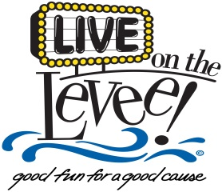

Thank you for your interest in playing in the *Live on the Levee* Concert Series. The concerts for *Live on the Levee* are every Friday night from Memorial Day to Labor Day. All concerts are outdoors and are subject to cancellation due to weather conditions. The concert series provides a stage, professional sound and lights at each event.

Email the completed application to renee.jones@cityofcharleston.org or mail to: Renee Jones, Special Events Coordinator, P.O. Box 2749, Charleston, WV 25330. A CD or flash drive can also be mailed with this application; however, website links are preferred. The deadline for submissions is February 15, 2019.

**CITY OF CHARLESTON**

**BAND APPLICATION**

|  |  |
| --- | --- |
| Name of Band: |  |
| Contact Name: |  |
| Phone Number: |  |
| Email: |  |
| Genre of music: |  |
| Recent appearances/festivals and approximate attendance: |  |
| How do you market your band? (Facebook, YouTube, newsletters, website, etc.) |  |
| Do you have performance samples online? Please include website. |  |
| Has your band ever performed at Live on the Levee? If so, when? |  |
| Is there anything else you would like to include about your band? |  |

**Revised January 2019**

**liveontheleveecharleston.com**