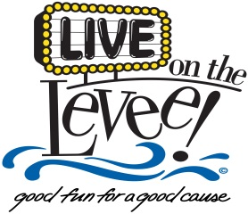

Thank you for your interest in playing in the *Live on the Levee* Concert Series. The concerts for *Live on the Levee* takes place every Friday night from Memorial Day to Labor Day. All concerts are outdoors and are subject to cancellation due to weather conditions. The concert series provides a stage, professional sound and lights at each event.

Email the completed application to lotlbands@cityofcharleston.org or mail to: Renee Jones, Special Events Coordinator, P.O. Box 2749, Charleston, WV 25330. A CD or flash drive can also be mailed with this application; however, website links are preferred. The deadline for submissions is February 7, 2020 at 5:00 p.m.

**CITY OF CHARLESTON**

**BAND APPLICATION**

|  |  |
| --- | --- |
| Band Name: |  |
| Contact Name: |  |
| Phone Number: |  |
| Email: |  |
| Genre of music: |  |
| Recent appearances/festivals and approximate attendance: |  |
| How do you market your band? Please include all social media links. |  |
| Do you have performance samples online? Please include website. |  |
| Has your band ever performed at Live on the Levee? If so, when? |  |
| Is there anything else you would like to include about your band? |  |

**If your band is chosen by the Committee to perform, a Certificate of Liability Insurance in the amount of $1,000,000 must be secured and include the City of Charleston as an additional insured for each event and must be received by the Special Events Coordinator 30 days prior to event.** **Also, you will be required to sign an Indemnity, Defense and Save Harmless Agreement with the City of Charleston.**

**Revised January 2020**

**liveontheleveecharleston.com**